7 Characteristics of Life
Below you see 7 pictures. By using your knowledge of the 7 characteristics of life and by examining the pictures it's your assignment to explain each characteristic of life best related to each picture.
The 7 characteristics are:
- Organization and Cells
- Response to Stimuli
- Homeostasis
- Metabolism
- Growth and Development
- Reproduction
- Change over time (Evolution)

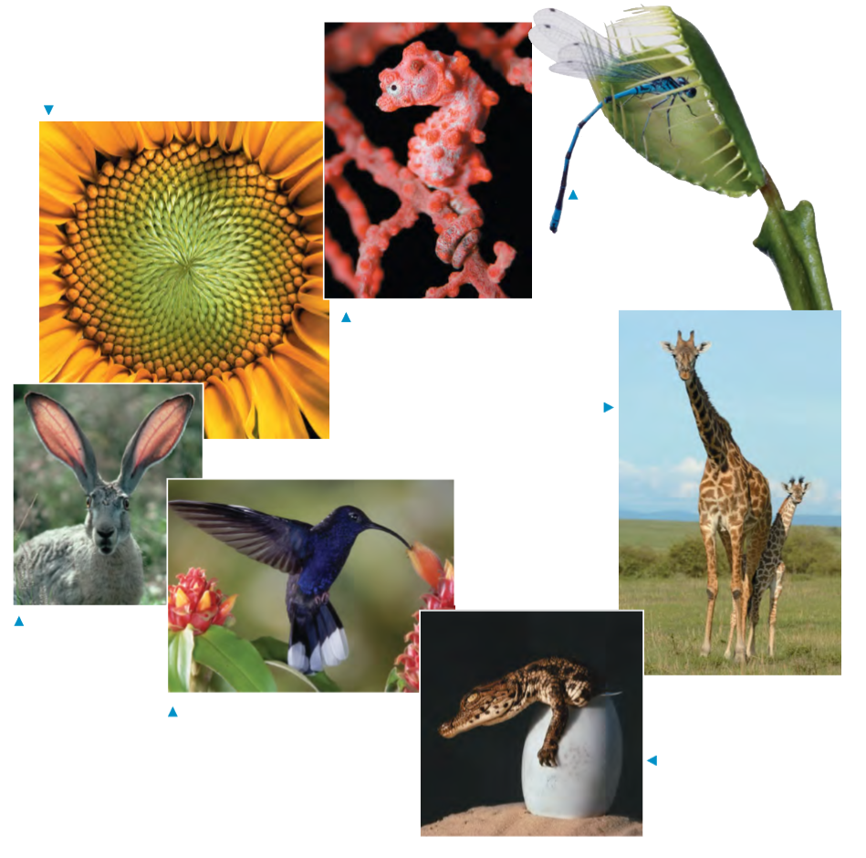

The names of the animals in the picture are:

Jackrabbit
Sunflower
Hummingbird
Sea horse
Venus flytrap
Giraffe
Crocodile

