Kidney Dissection Guide

In this activity, you will examine the outside of a pig kidney and then cut it open to see and identify the structures inside the kidney.
To get full credit for this activity, your group will need to do 3 things:
1) Follow the instructions in this dissection guide to identify all the structures in the kidney.
2) After your group has identified all the structures in the kidney, your group should use your kidney to show me the path taken through the kidney by the blood, and by the filtrate that becomes the urine. As you explain this, you should point out and name all the structures that are involved.
3) Take pictures with your phone of the kidney to label the organ with all the parts described in the Dissection Instruction.

Safety:
Handle sharp instruments with caution. Always point them and cut away from yourself and anyone else who is nearby.
When you have finished, clean all your tools with detergent and put them away.
Wash your hands with detergent and warm water before leaving the lab.

Dissection Instructions
1. Examine the outside of the kidney. The ureter, renal artery, and renal vein all enter the kidney in the same area. If they are present, the ureter can be identified by the larger amount of fat tissue that is usually attached to it.
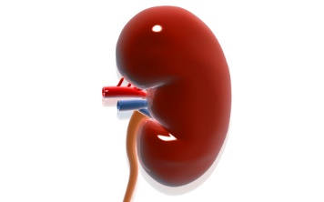
2. Identify the ureter, renal artery, and renal vein if they are present.
3. Letting the kidney lie flat as shown in the figure at left, cut the kidney in half lengthwise from the side. Do not cut until you have checked and are sure of the correct direction of your cut—As a surgeon, you only get one chance to cut, and there is no way to redo this.
4. Splitting the kidney in half will reveal its internal structures. Examine the kidney and the diagram on page 2 to identify these structures.

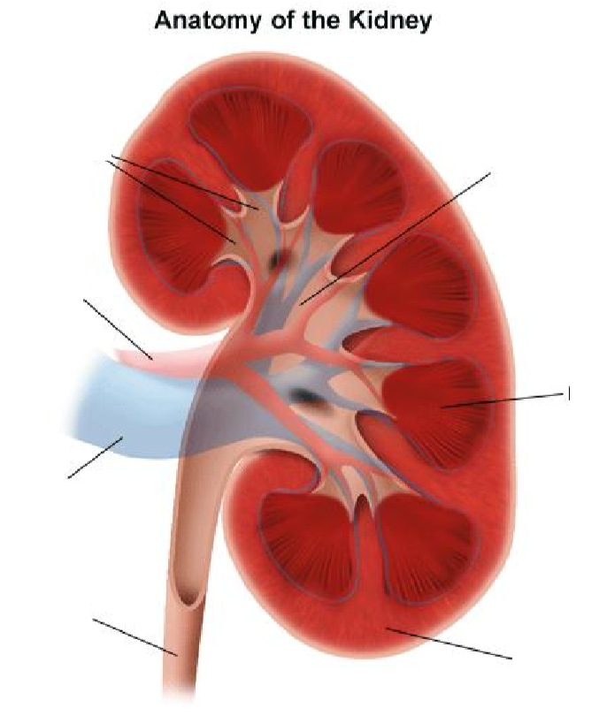
5. There are several parts to the kidney, as show at right. From the outside to the center of the kidney, find each of the following in your specimen:
- The renal cortex is the solid looking outermost part of the kidney. It contains many small arteries and veins that carry blood to and from approximately one million nephrons located in the cortex.

- The medulla is the region located inward from the cortex. It includes the cone shaped renal pyramids. These are the fibrous or striped triangular zones in the medulla that contain the colleting ducts, which collect urine from the kidney tubules of the nephrons in the cortex. Between the pyramids are the renal columns that contain middle-sized arteries and veins that carry blood between the nephrons in the cortex and the renal artery and vein.

- The hollow area in the center of the kidney is the renal pelvis, which should not be confused with the bone called the pelvis. The collecting ducts drain into the pelvis. From there, the urine passes out through the ureter to the urinary bladder.

6. After you have identified all the structures in the kidney, work with your group to trace the path taken through your group’s kidney by the blood, and by the filtrate that becomes the urine. As you do this, point out and name all the structures that are involved. When your group is satisfied that you can do this well, your group should use the kidney to explain it to me.
7. When you have finished using the kidney, I will give you some plastic to wrap it up. Clean all your equipment thoroughly with detergent and water and return it. Use paper towels, detergent, and water to clean up your work area. All group members are responsible for clean-up.
8. After your group has finished cleaning up, wash your hands well with detergent and water.

Questions
Consider these questions as you prepare to dissect the kidney. Think about your responses as you go forward through the lab. These questions will need to be answered in complete sentences and handed in to the teacher during the following class.

1. What is the main function of the kidney?
2. Describe the pathway of blood through the kidney.
3. How did you distinguish between the renal artery and the renal vein?
4. Which area of the kidney contains the glomeruli and Bowman’s capsules?
5. In which part of the kidney does the majority of water reabsorption occur?
6. What structure carries urine out of the kidney and where does it go?

